# Introduction to visuals in Power BI

Visuals allow you to present data in a compelling and insightful way, and help you show the important components of it. Power BI has many compelling visuals and many more that are released frequently.

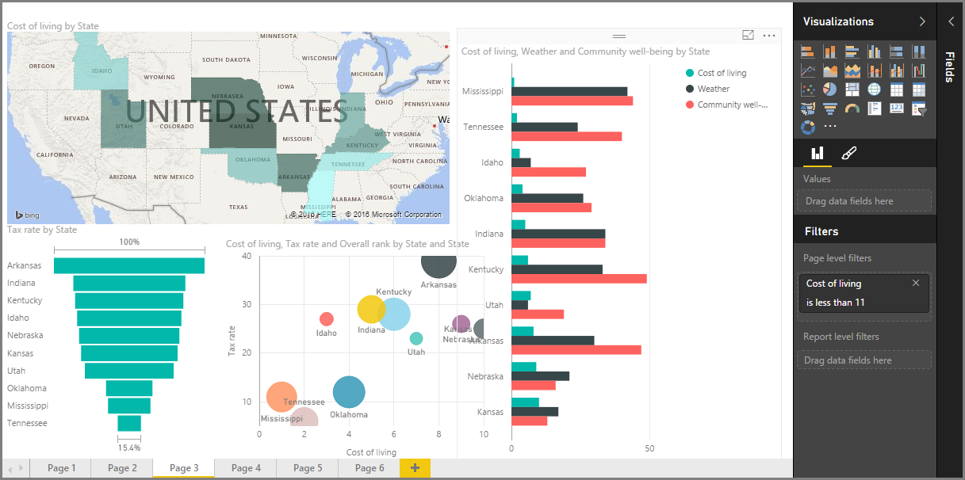

Visualizing data is one of the core parts and basic building blocks of Power BI. Creating visuals is one of the most effective ways to find and share your insights.

We will use the **Financial Data** from the course moodle page

# Create and customize simple visualizations

Two ways to create a new visualization in Power BI Desktop are:

Drag field names from the Fields pane and then drop them on the report canvas. By default, your visualization appears as a table of data.

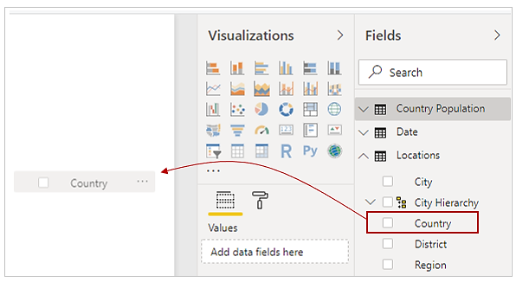

In the Visualizations pane, select the type of visualization that you want to create. With this method, the default visual is a blank placeholder that resembles the type of visual that you selected.

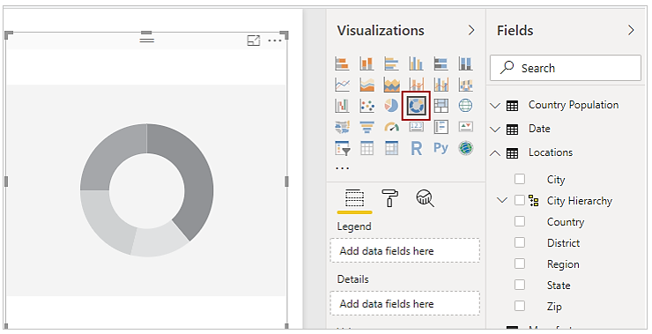

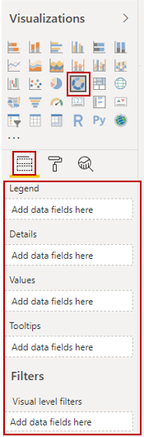

After you have created your graph, map, or chart, you can begin dragging data fields onto the bottom portion of the Visualization pane to build and organize your visual. The available fields will change based on the type of visualization that you selected. As you drag and drop data fields, your visualization will automatically update to reflect changes.

You can resize your visual by selecting it and then dragging the handles in or out. You can also move your visualization anywhere on the canvas by selecting and then dragging it to where you want it. If you want to convert between different types of visuals, select the visual that you want to change and select a different visual from the Visualization pane. Power BI attempts to convert your selected fields to the new visual type as closely as possible.

As you hover over parts of your visuals, you'll receive a tooltip that contains details about that segment, such as labels and total value.

Select the paintbrush icon on the Visualizations pane to make cosmetic changes to your visual. Examples of cosmetic changes include background alignment, title text, and data colours.

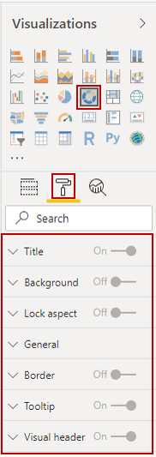

## Create combination charts

You might want to visualize two measures with different scales, such as revenue and units. Use a combination chart to show a line and a bar with different axis scales. Power BI supports many different types of combination charts by default, including Line and Stacked Columns charts.

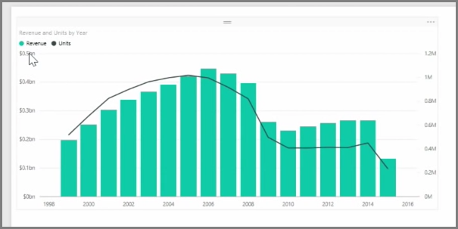

You can split each column by category by dragging a category into the Column Series field. When you do so, each bar is proportionately coloured based on the values within each category.

## Create slicers

Slicers are one of the most powerful types of visualizations, particularly as part of a busy report. A slicer is an on-canvas visual filter that allows report users to segment the data by a specific value. Examples of filters include by year or by geographical location.

To add a slicer to your report, select **Slicer** from the Visualizations pane. 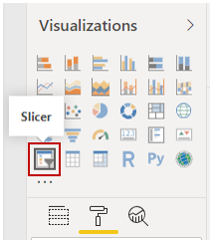

Drag the field by which you want to slice and drop it to the top of the slicer placeholder. The visualization turns into a list of elements with check boxes. These elements are your filters. Select the box next to the one that you want to segment, and Power BI will filter, or slice, all other visuals on the same report page.

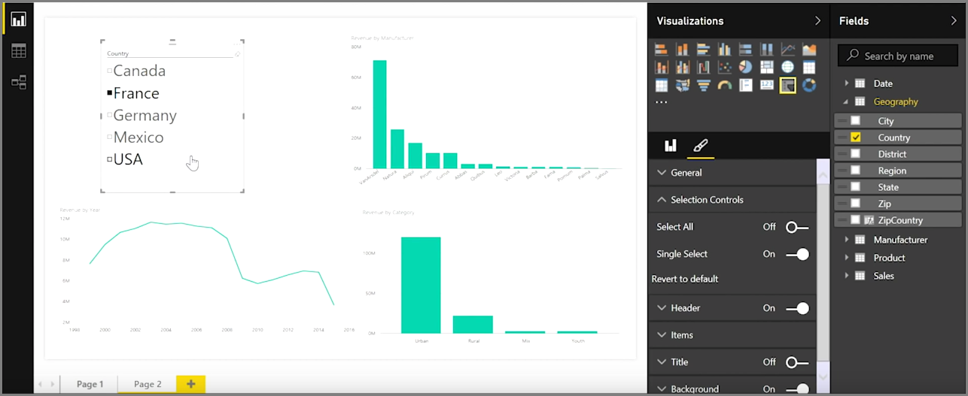

A few different options are available to help you format your slicer. You can set it to accept multiple inputs at once, or you can use the Single Select mode to use one at a time. You can also add a Select All option to your slicer elements, which is helpful when you have a long list. Change the orientation of your slicer from the vertical default to horizontal, and it becomes a selection bar rather than a checklist.

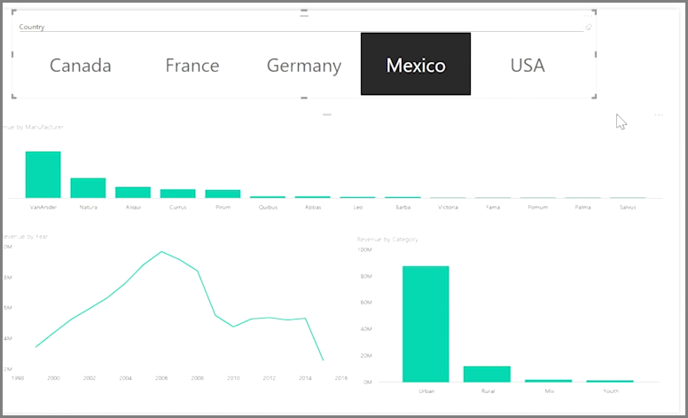

When you have multiple visualizations on the same report page, Power BI Desktop lets you control how interactions flow between visuals

## Map visualizations

Power BI has two different types of map visualizations: a bubble map that places a bubble over a geographic point, and a shape map that shows the outline of the area that you want to visualize.

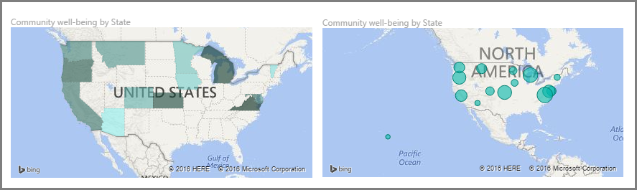

When you are working with countries or regions, use the three-letter abbreviation to ensure that geocoding works properly. Do not use two-letter abbreviations because some countries or regions might not be properly recognized.

If you only have two-letter abbreviations, go to this external blog post for steps on how to associate your two-letter country and/or region abbreviations with three-letter country and/or region abbreviations.

### Create bubble maps

To create a bubble map, select the Map option in the Visualization pane. In the Visualizations options, add a value to the Location bucket to use a map visual.

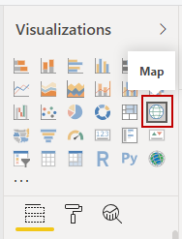

Power BI accepts many types of location values. It recognizes city names, airport codes, or specific latitude and longitude data. Add a field to the Size bucket to change the size of the bubble for each map location.

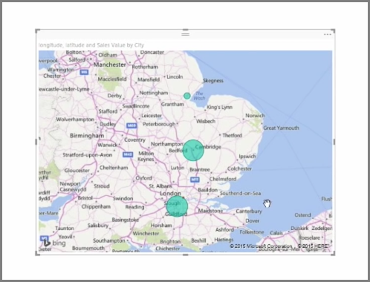

### Create shape maps

To create a shape map, select the **Filled Map** option in the Visualization pane. As with bubble maps, you must add a value to the Location bucket to use this visual. Add a field to the Size bucket to change the intensity of the fill colour.

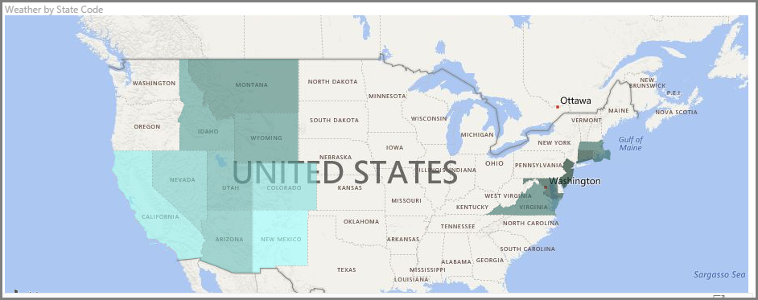

A warning icon in the top-left corner of your visual indicates that the map needs more location data to accurately plot values. This is a common problem when the data in your location field is ambiguous, such as using an area name like Washington, which could indicate a state or a district.

One way to resolve the location data problem is to rename your column to be more specific, such as State. Another way is to manually reset the data category by selecting Data Category on the Modeling tab. From the Data Category list, you can assign a category to your data such as "State" or "City."

## Matrices and tables

You can use Power BI Desktop to create graphical and tabular visuals.

If you have numerical information in a table, such as revenue, a total sum will appear at the bottom. You can manually sort by each column by selecting the column header to switch ascending or descending order. If a column isn't wide enough to display all its contents, select and drag the column header to expand it.

In the Visualizations pane, the order of the fields in the Values bucket determines the order in which they appear in your table.

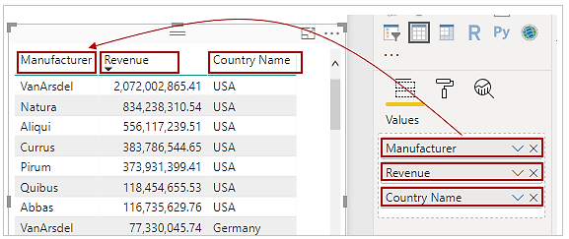

A matrix is like a table, but it has different category headers on the columns and rows. As with tables, numerical information will be automatically totalled along the bottom and right side of the matrix.

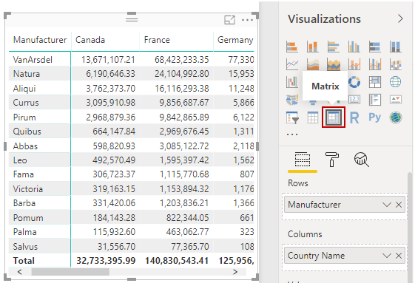

Many cosmetic options are available for matrices, such as auto-sizing columns, switching between row and column totals, setting colours, and more.

## Create scatter, waterfall, and funnel charts

Use a scatter chart to compare two different measures, such as unit sales versus revenue.

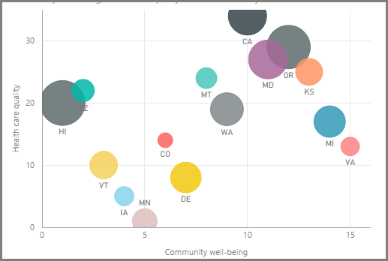

To create a blank chart, select Scatter chart from the Visualizations pane. Drag and drop the two fields that you want to compare from the Fields pane to the X Axis and Y Axis option buckets. At this point, your scatter chart probably has a small bubble in the centre of the visual. You need to add a measure to the Details bucket to indicate how you want to segment your data. For example, if you're comparing item sales and revenue, you might want to split the data by category, or manufacturer, or month of sale.

Adding another field to the Legend bucket will colour code your bubbles according to the field's value. You can also add a field to the Size bucket to alter the bubble size according to that value.

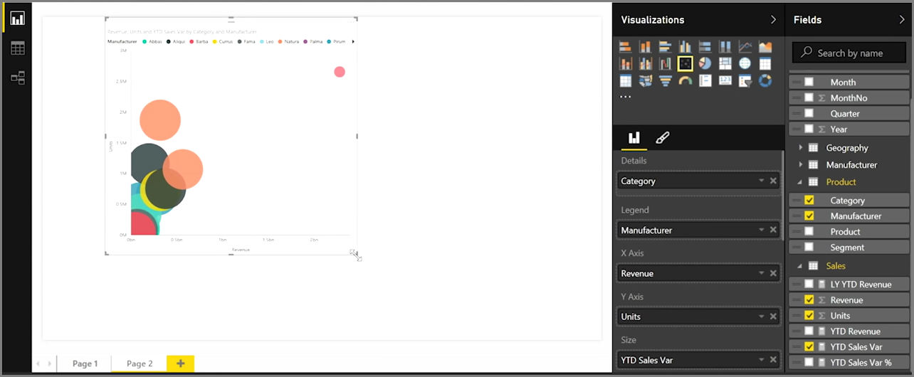

Scatter charts have many visual formatting options as well, such as turning on an outline for each coloured bubble and switching between individual labels. You can change the data colours for other chart types as well.

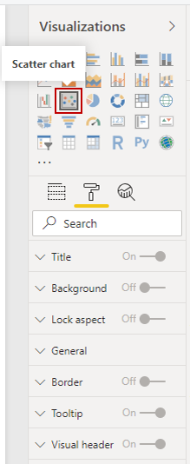

You can create an animation of your bubble chart's changes over time by adding a time-based field to the Play Axis bucket. Select a bubble during an animation to see a trace of its path.

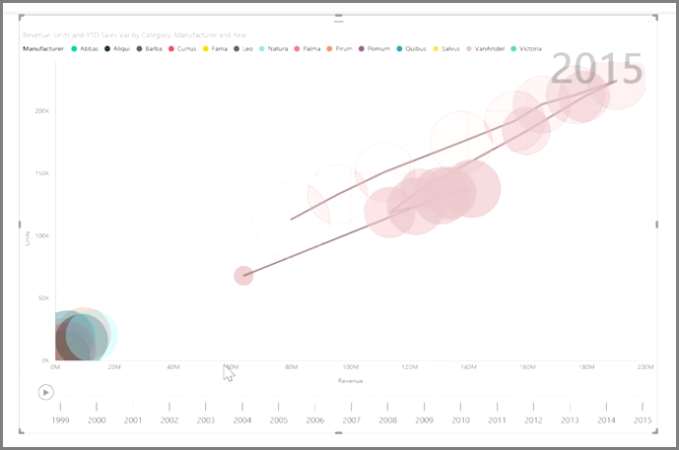

*Remember, if you only see one bubble in your scatter chart, it's because Power BI is aggregating your data, which is the default behaviour. To get more bubbles, add a category to the Details bucket in the Visualizations pane.*

## Create waterfall and funnel charts

Waterfall and funnel charts are two of the more noteworthy (and uncommon) standard visualizations that are included in Power BI. To create a blank chart of either type, select its icon from the Visualizations pane.

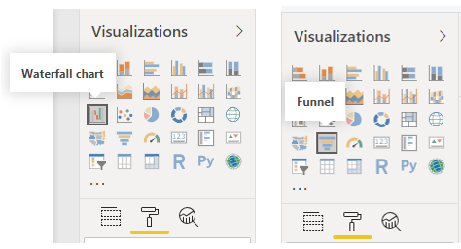

Waterfall charts are typically used to show changes in a specific value over time.

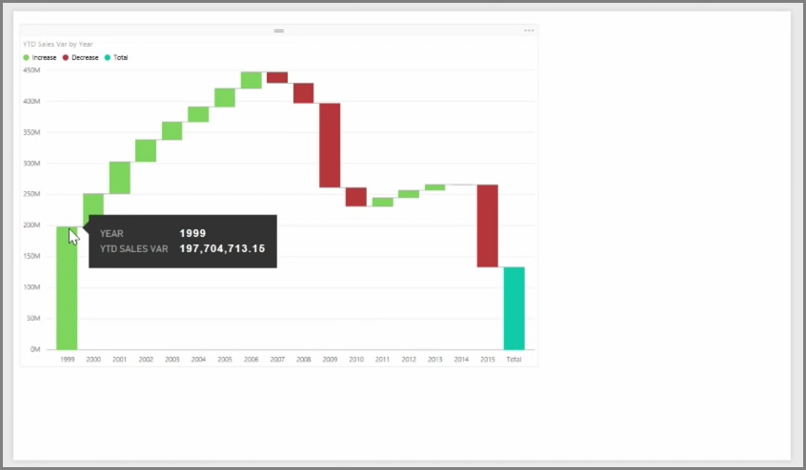

Waterfalls only have two bucket options: Category and Y Axis. Drag a time-based field, such as Year, to the Category bucket, and drag the value that you want to track to the Y Axis bucket. Time periods where an increase in value occurred are displayed in green by default, while periods with a decrease in value are displayed in red.

Funnel charts are typically used to show changes over a specific process, such as a sales pipeline or website retention efforts.

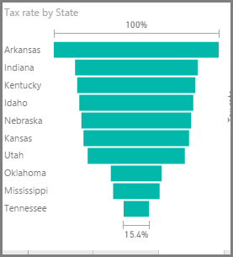

You can slice and customize Waterfall and Funnel charts.

## Modify colours in charts and visuals

Occasionally, you might want to modify the colours that are used in charts or visuals. Power BI gives you control over how colours are displayed. To begin, select a visual and then select the paintbrush icon in the Visualizations pane.



Power BI provides many options for changing the colour or formatting the visual. You can change the colour of all bars in a visual by selecting the colour picker beside Default colour and then selecting your colour of choice.

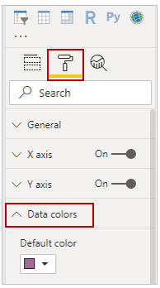

You can change the colour of each bar (or other element, depending on the type of visual that you selected) by turning the Show all slider to On. A colour selector will then appear for each element.

### Conditional formatting

You can change the colour based on a value or measure. To do so, select the vertical ellipsis next to Default colour.

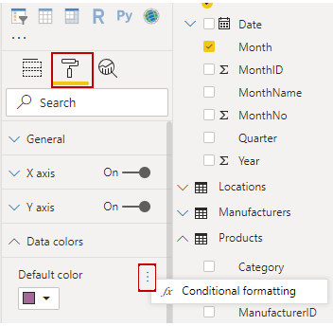

The resulting visuals will be coloured by the gradient that you select.

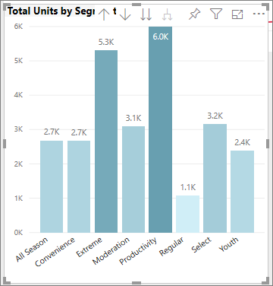

You can use those values to create rules, for example, to set values above zero to a certain colour and values below zero to another colour.

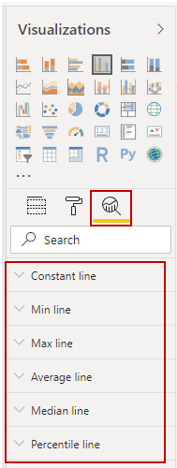

In the Analytics pane, you can create many other lines for a visual, such as Min, Max, Average, Median, and Percentile lines.

You can create a border around an individual visualization, and like other controls, you can specify the colour of that border as well.